I
n this session we will look at what is event sub process and how it functions ?.

Event subprocess is a subprocess that is triggered by an event. An event subprocess can be added at the process level or at any subprocess level.
- The event used to trigger an event subprocess is configured using a start event. Therefore, none start events are not supported for event subprocesses.
- An event subprocess might be triggered using events like message events, error events, signal events, timer events, or compensation events.
- The subscription to the start event is created when the scope (process instance or subprocess) hosting the event subprocess is created. The subscription is removed when the scope is ended.

Camunda event sub process
- An event subprocess may be interrupting or non-interrupting. An interrupting subprocess cancels any executions in the current scope. A non-interrupting event subprocess spawns a new concurrent execution. While an interrupting event subprocess can only be triggered once for each activation of the scope hosting it, a non-interrupting event subprocess can be triggered multiple times. Whether the subprocess is interrupting or non-interrupting is configured using the start event which triggers the event subprocess.
- An event subprocess may not have any incoming or outgoing sequence flows. As an event subprocess is triggered by an event, an incoming sequence flow makes no sense. When an event subprocess is ended, either the current scope is ended (in case of an interrupting event subprocess), or the concurrent execution spawned for the non-interrupting subprocess is ended.

1. To demonstrate the use of event sub process we will model below process diagram.
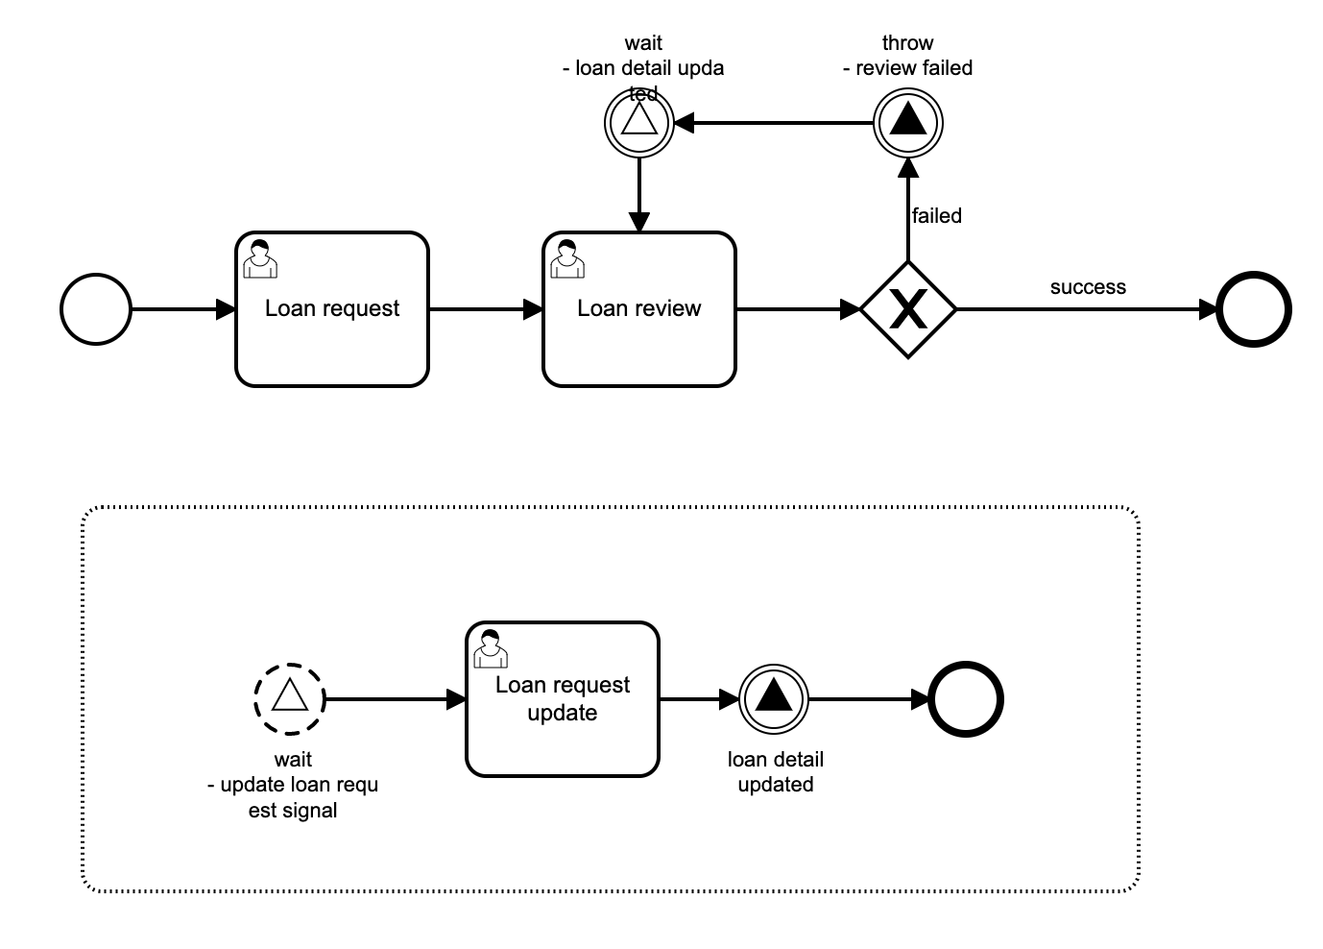

Id: Process_event_subprocess_signal
Name: Process event subprocess signal

2. User task: Loan request
Id: Activity_1g1gefr
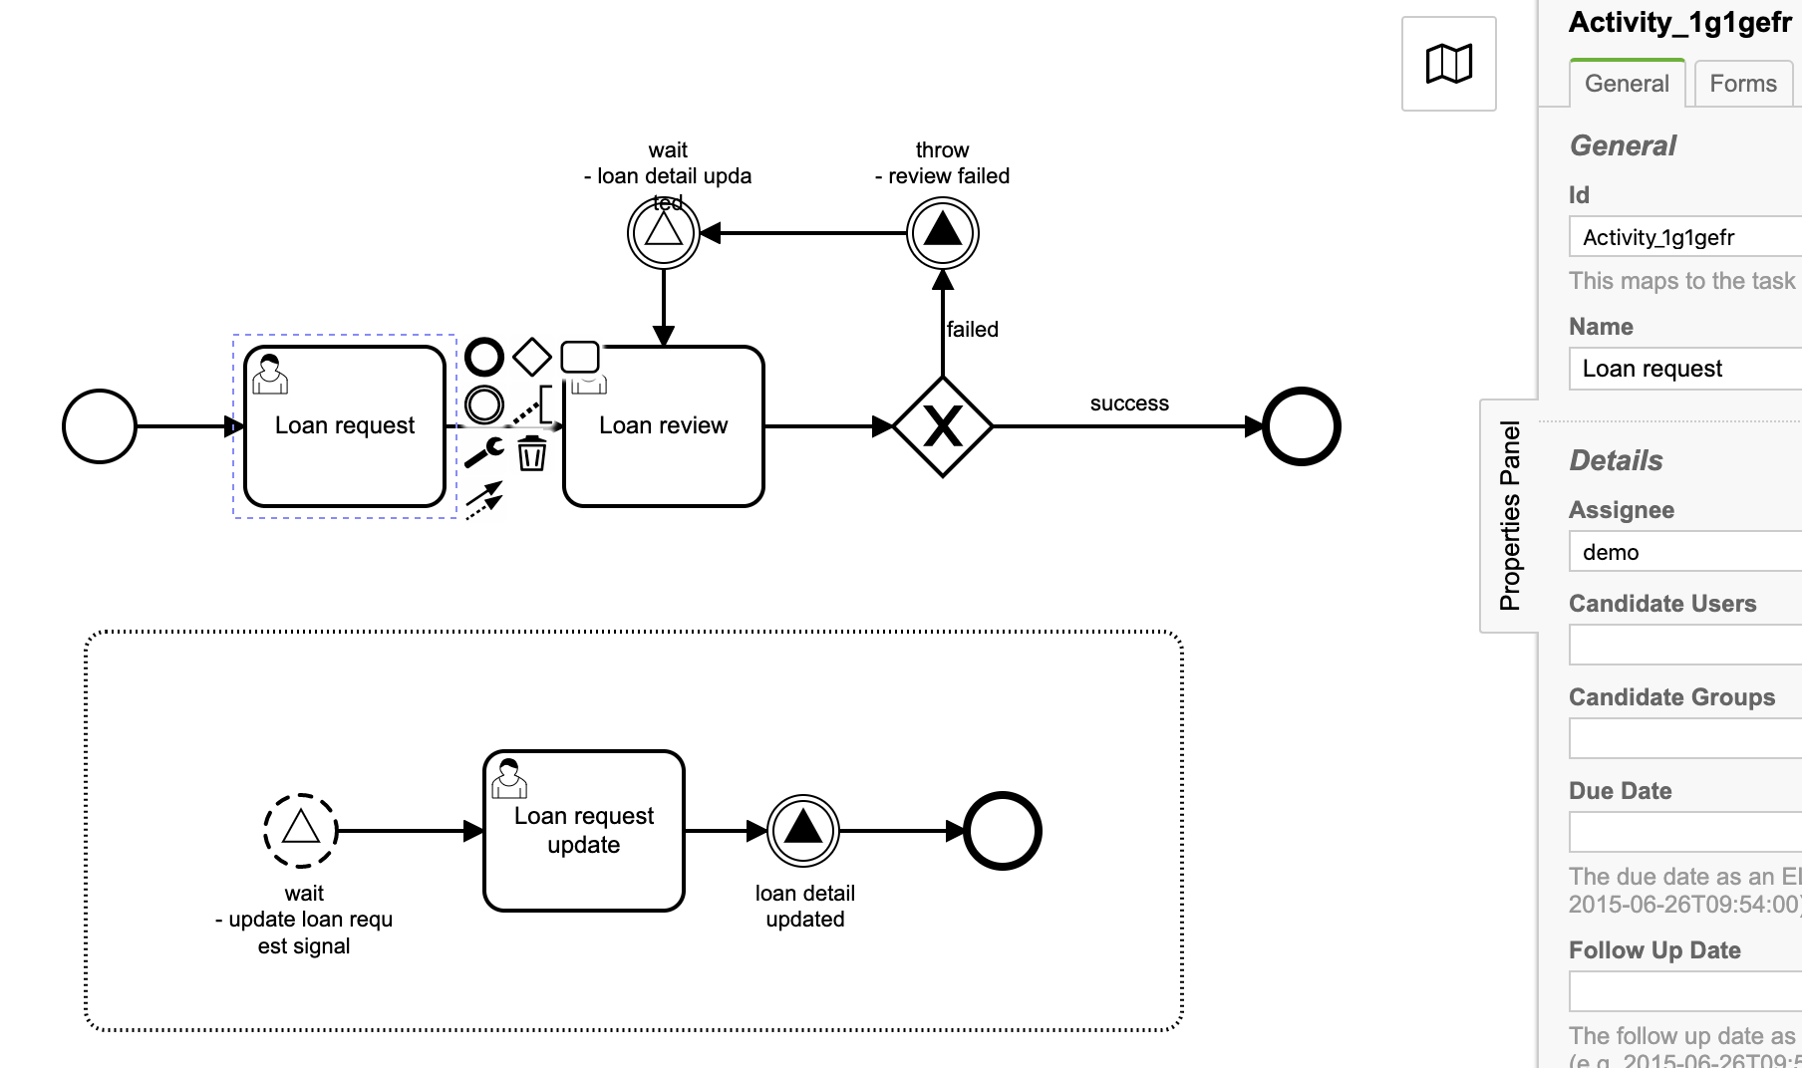
Name: Loan request
Assignee: demo

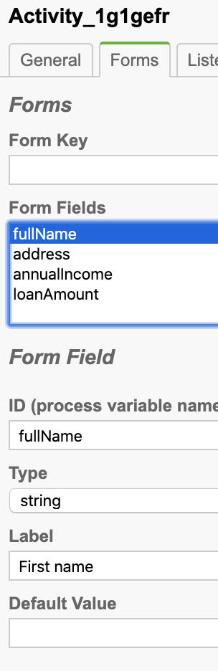
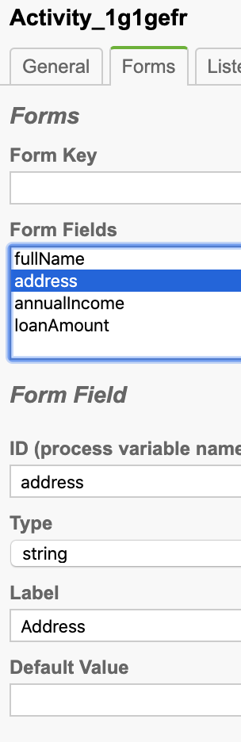
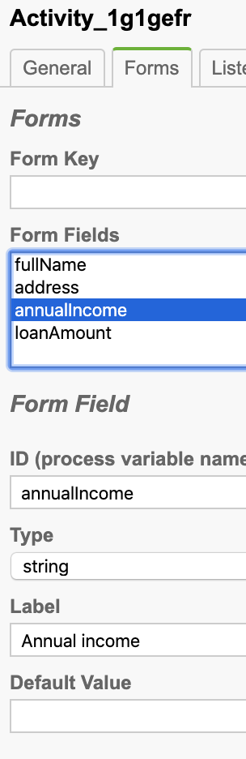
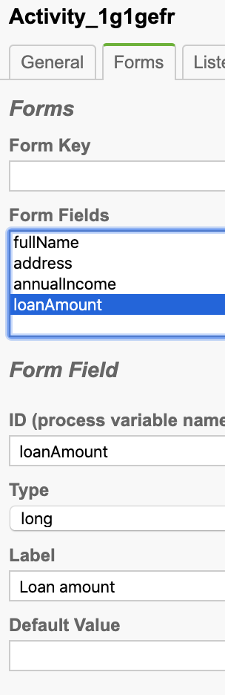
Task form

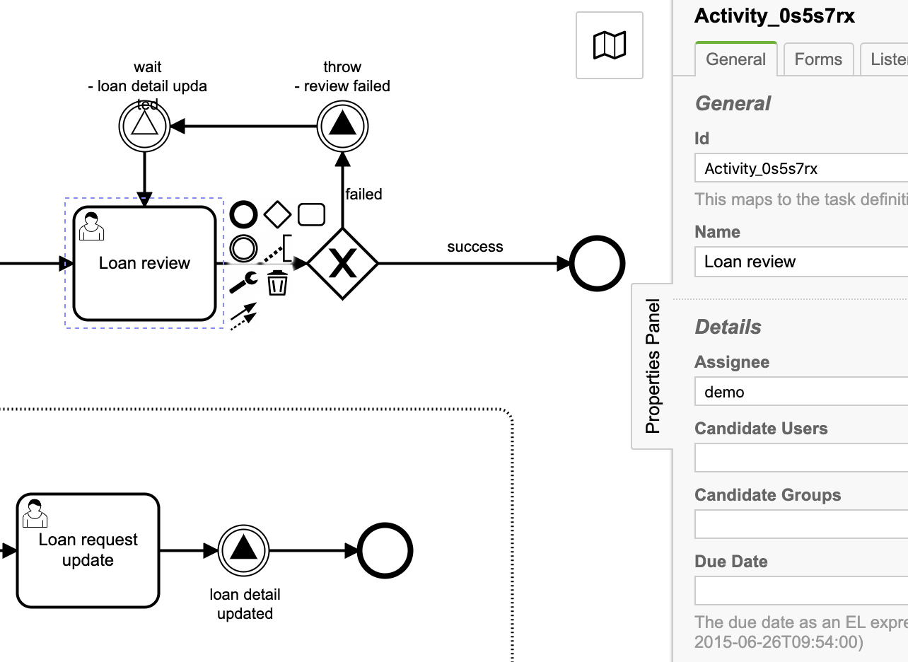
3. User task: Loan review
Id: Activity_0s5s7rx
Name: Loan review
Assignee: demo

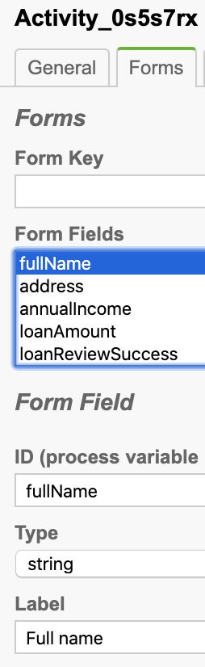
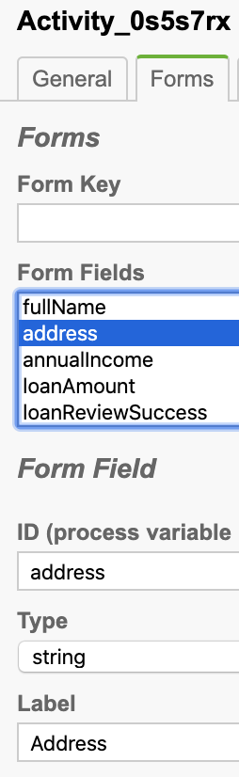
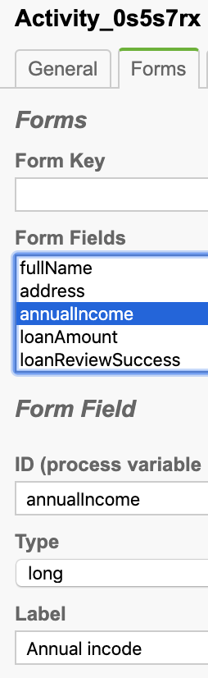
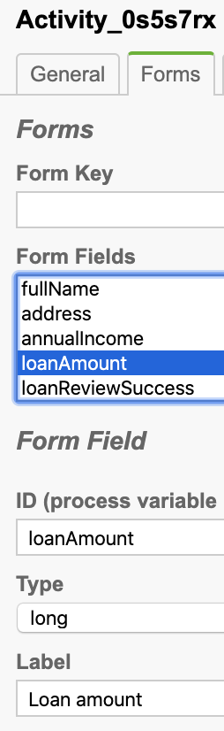
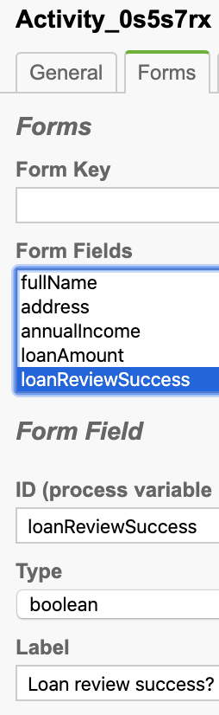
Task form

4. Flow sequence conditions

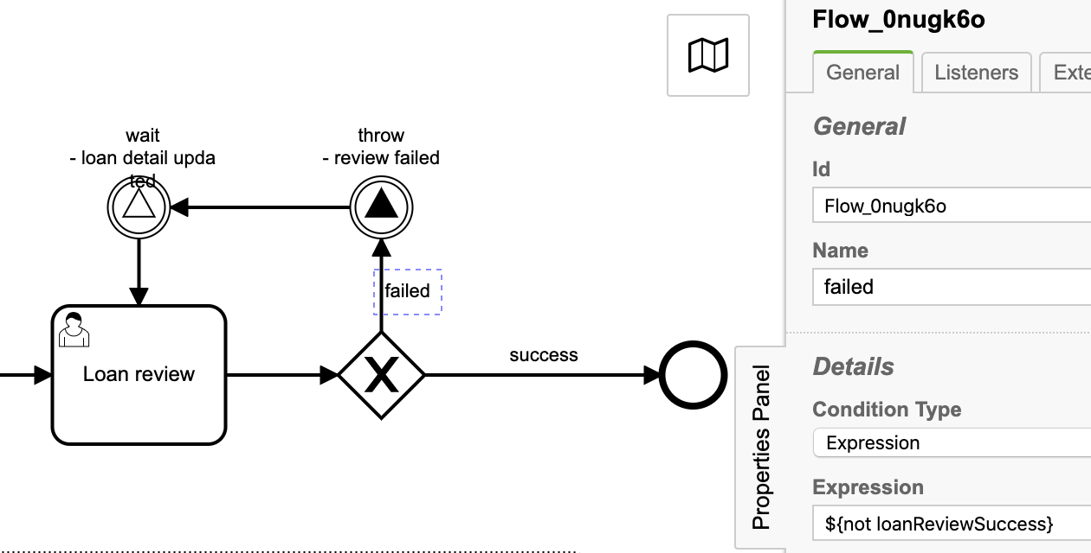
Failed:
Id: Flow_0nugk6o
Name: failed
Condition Type: Expression
Expression: ${not loanReviewSuccess}

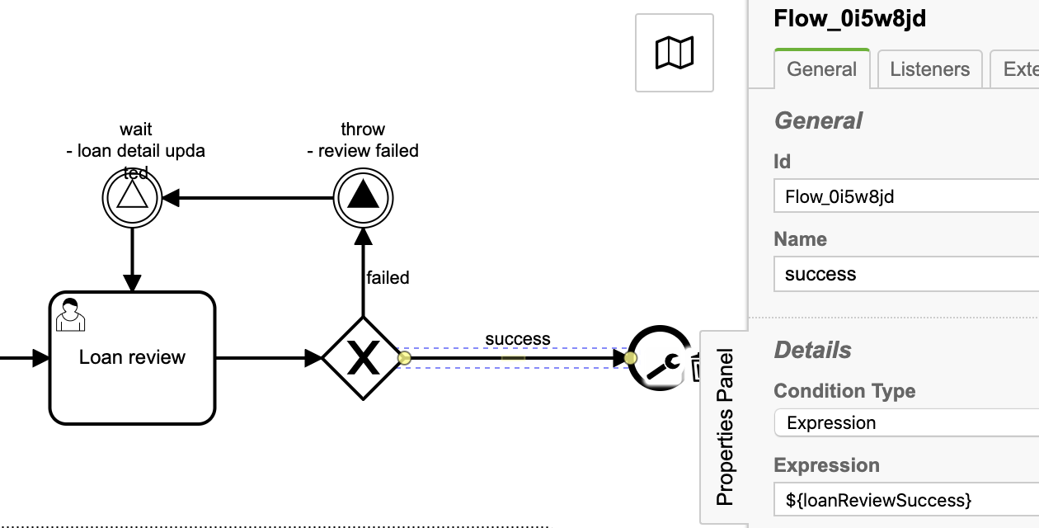
Success:
Id: Flow_0i5w8jd
Name: success
Condition Type: Expression
Expression: ${loanReviewSuccess}

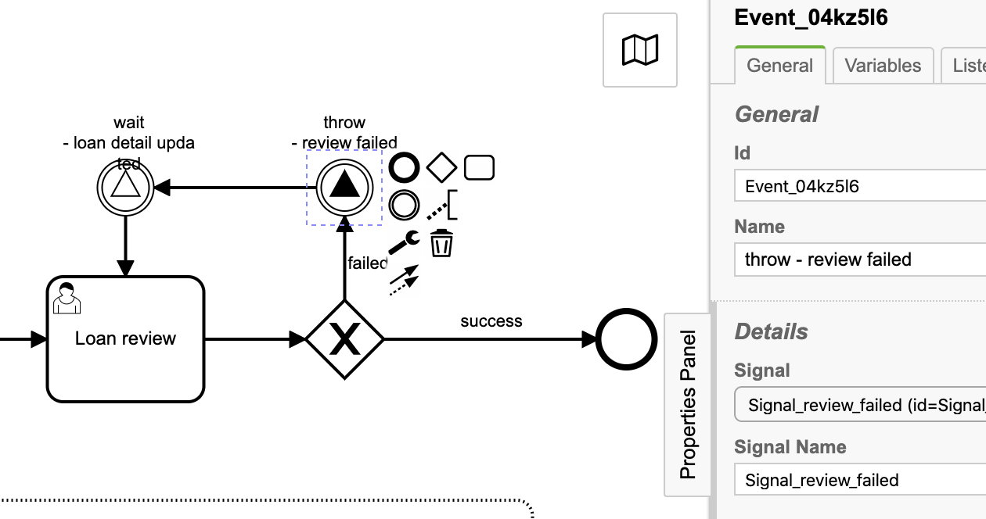
5. Intermediate signal throw event: throw - review failed

Id: Event_04kz5l6
Name: throw - review failed
Signal: Signal_review_failed (id=Signal_0lykxsy)
Signal Name: Signal_review_failed

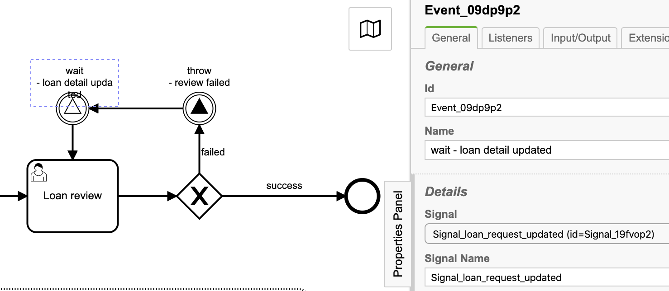
6. Intermediate signal catch event: wait - loan detail updated
Id: Event_09dp9p2
Name: wait - loan detail updated
Signal: Signal_loan_request_updated (id=Signal_19fvop2)
Signal Name: Signal_loan_request_updated

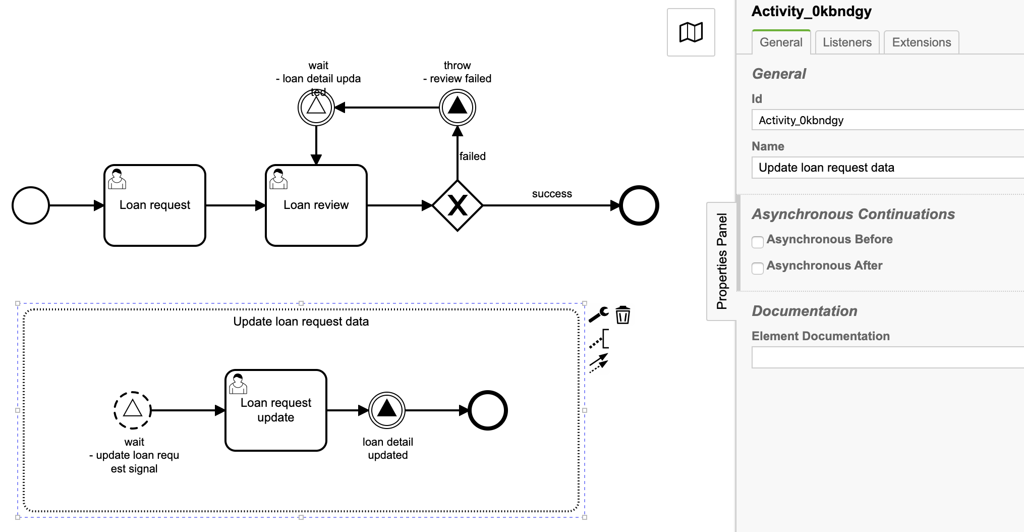
7. Event subprocess - Update loan request data
Id: Activity_0kbndgy
Name: Update loan request data

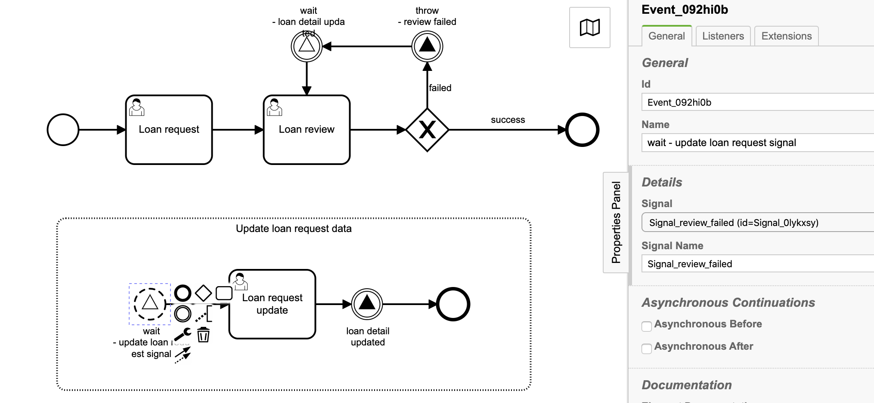
8. Non interrupting start signal event: wait - update loan request signal
Id: Event_092hi0b
Name: wait - update loan request signal
Signal: Signal_review_failed (id=Signal_0lykxsy)
Signal Name: Signal_review_failed

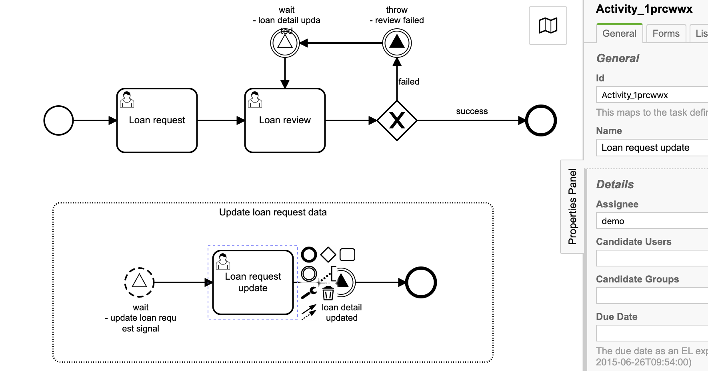
9. User task: Loan request update
Id: Activity_1prcwwx
Name: Loan request update
Assignee: demo

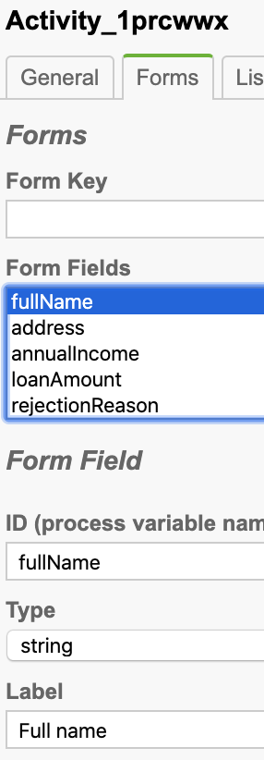
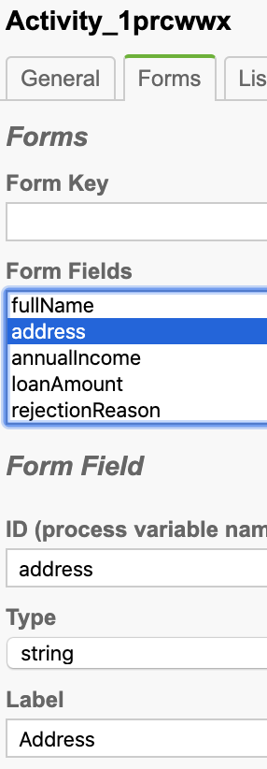
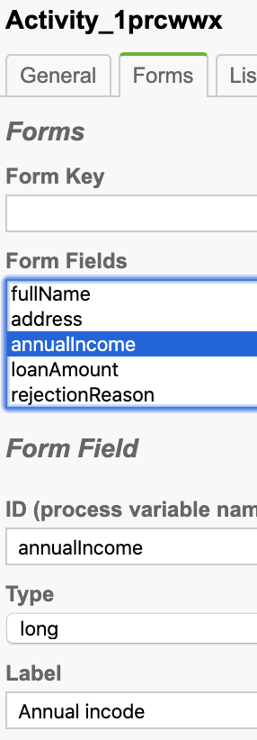
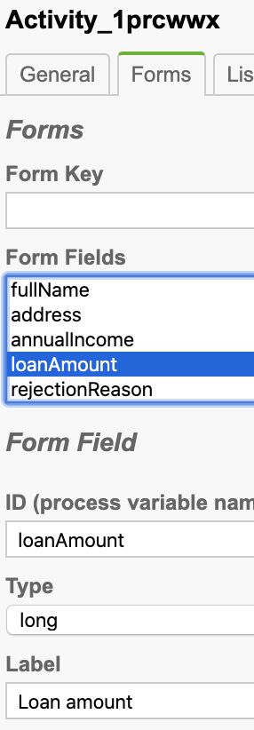
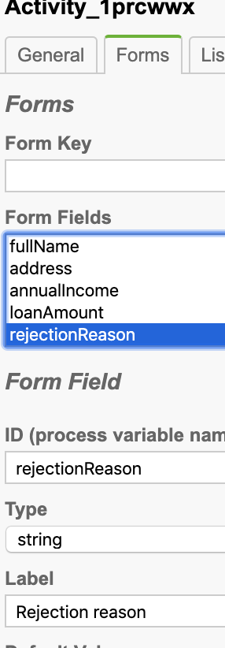
Task form

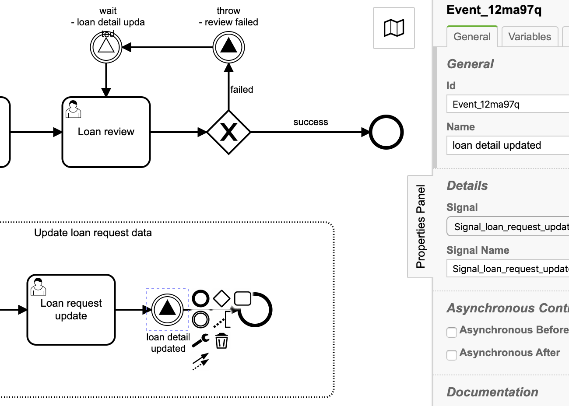
10. Intermediate signal throw event: loan detail updated

Id: Event_12ma97q
Name: loan detail updated
Signal: Signal_loan_request_updated (id=Signal_19fvop2)
Signal Name: Signal_loan_request_updated

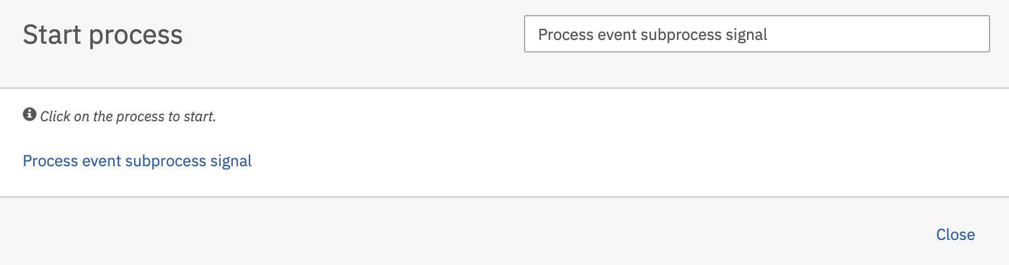
Deploy and start the process

Hit the Process event subprocess signal and hit the Start button to start the process.

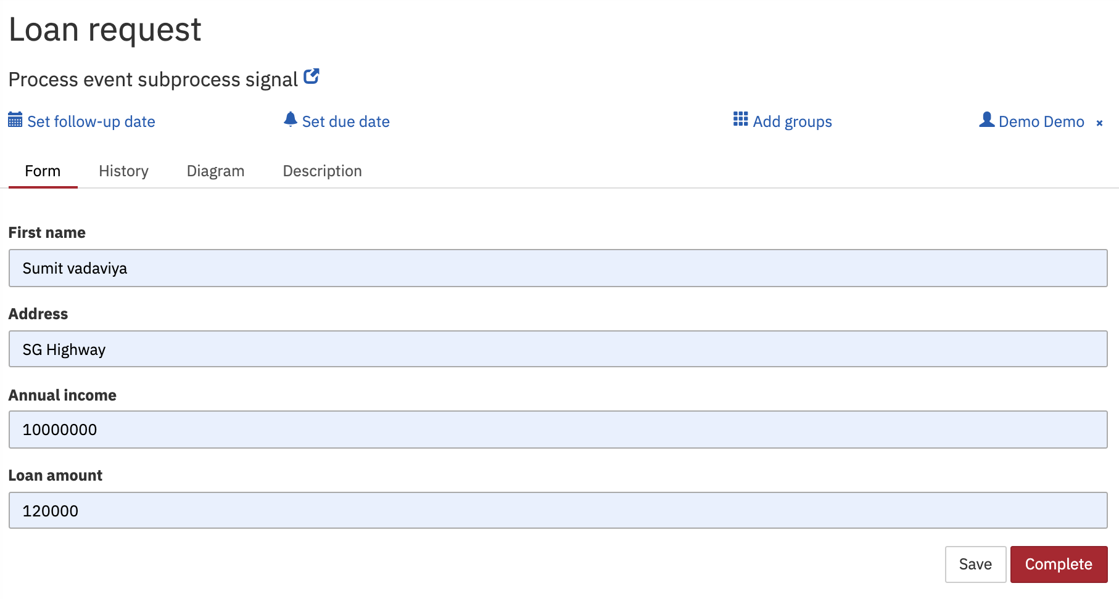
As per process definition, User task Loan request will be created.
Fill it up and hit the Complete button.

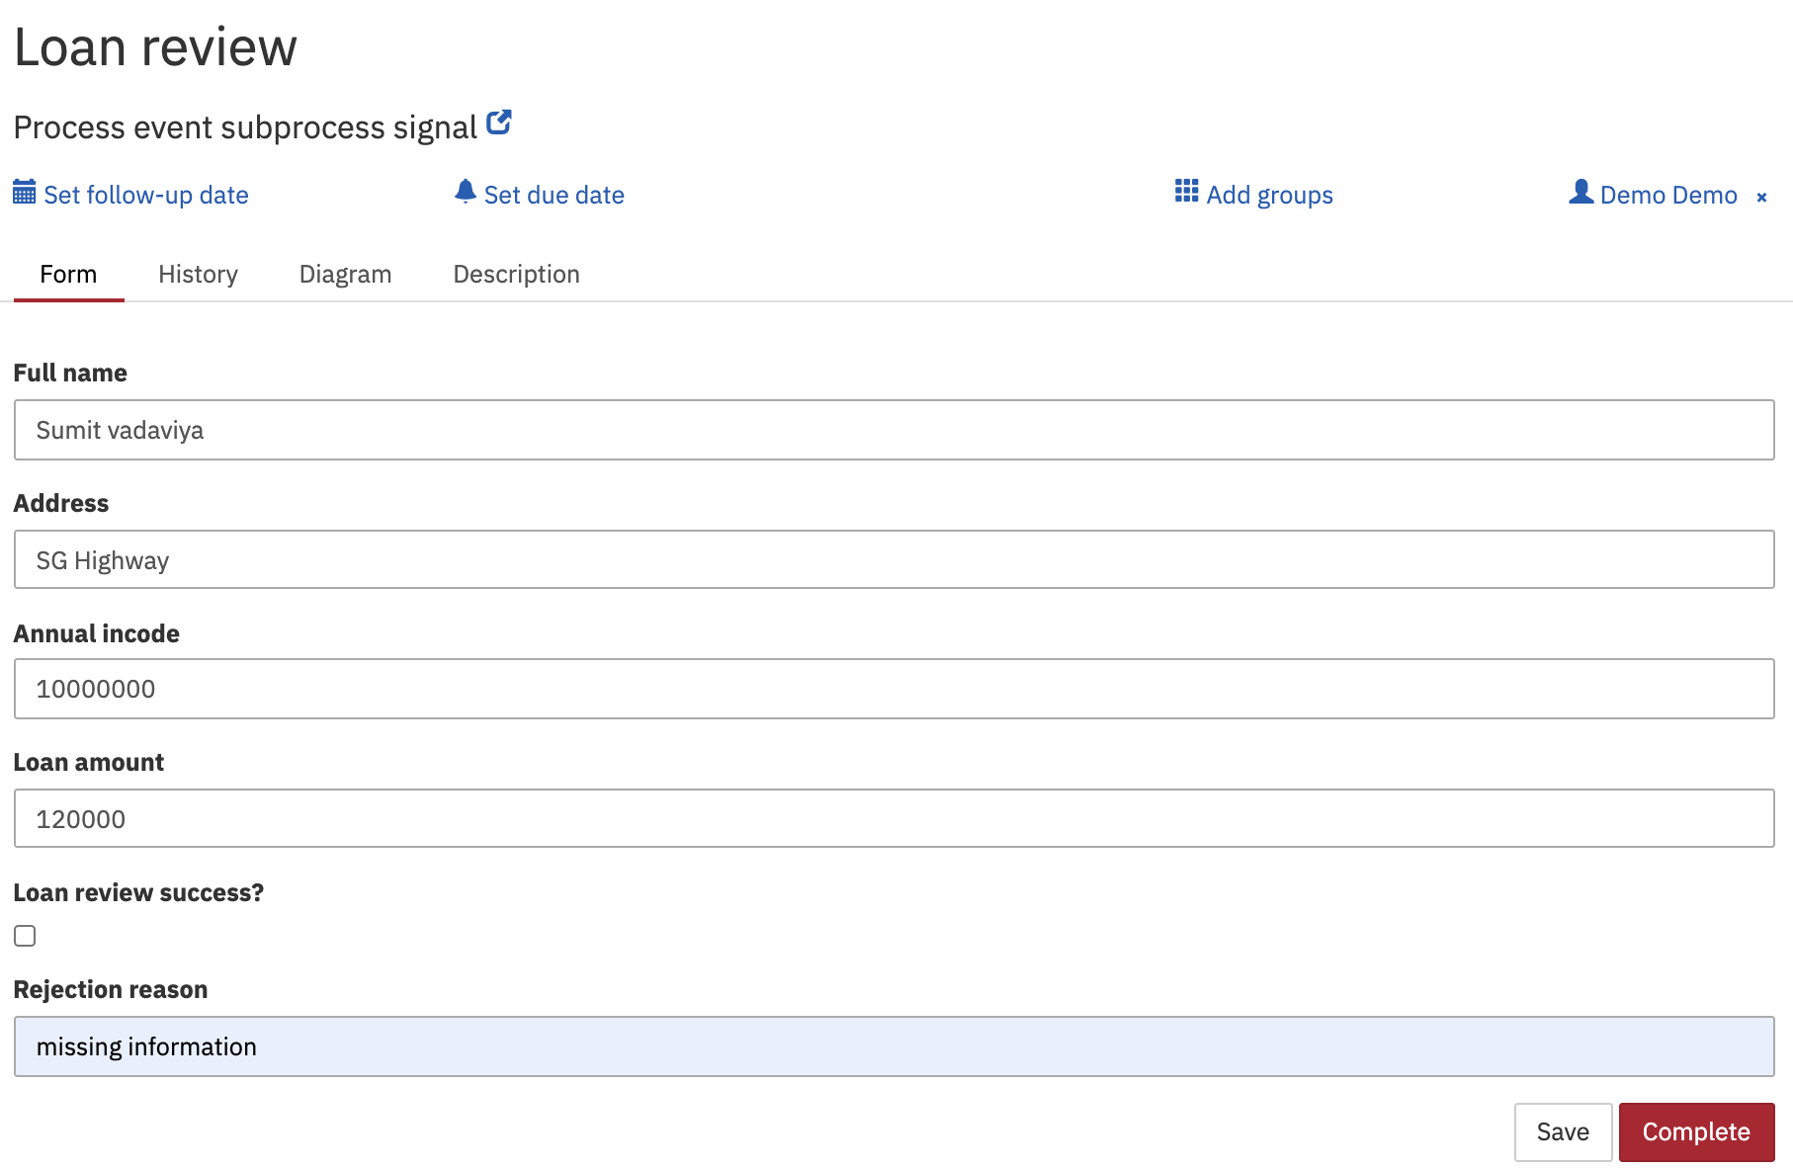
User task Loan review will get created.
Fill-up the task form and press the Complete button.

As per process definition, Intermediate throw signal event (throw - review failed) will be thrown and it will be caught by event subprocess’s start signal event(wait - update loan request signal).
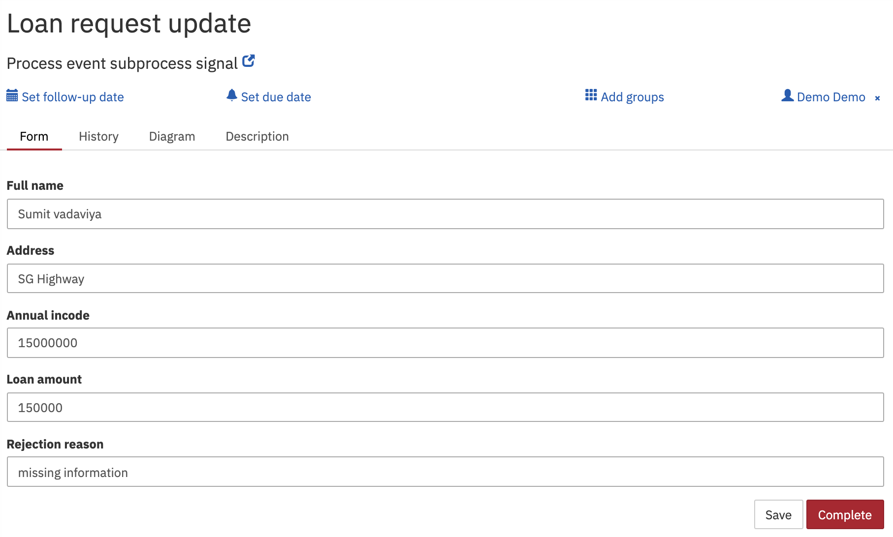
Fill-up the form and hit the Complete button.

As per event subprocess definition, again intermediate throw signal event(loan detail updated) will be thrown and same will be received by signal intermediate catch event(wait - loan detail updated) in parent process and again user task Loan review will be created.

